#1: Introducing logic grids

- Peter's birthday is in April.
- Eric is 7.
- Arnold's birthday is in September.
- Peter is 8.

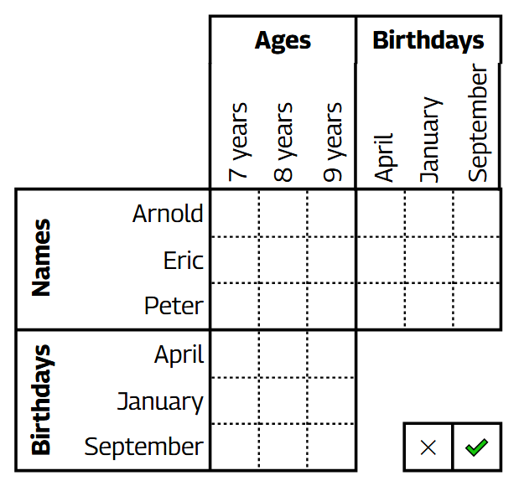

From https://www.brainzilla.com/logic/logic-grid/basic-1/.
#2: Key deductions

Each box is locked. They all require different keys to be opened, and there are no copies. You are given keys to boxes 1,2,3, which are not in any other box. Besides boxes 1,2,3, 6 of the other boxes contain a single key, while two of the remaining contain nothing and the third a prize. Which box 1,2,3, when opened, leads to a sequence of keys and openings that gives you the prize? The longest sequence of boxes ends with the box with the prize, and all keys are retrievable.

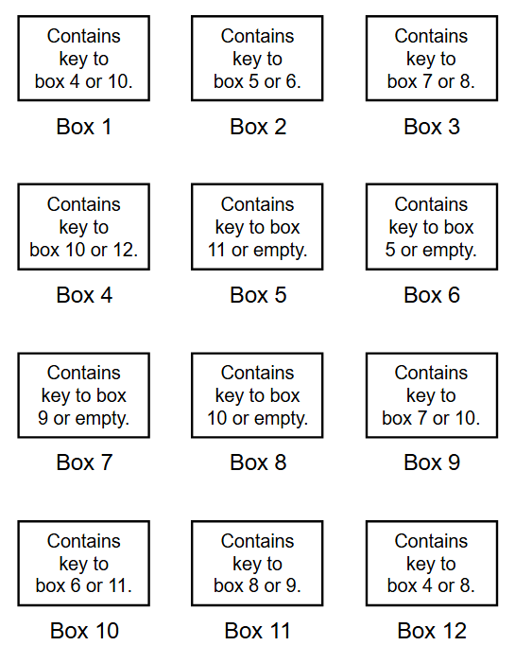

From Return to Montague Island, puzzle 1.1.
#3: Who’s the liar?

Fatima and Amara come from a land where some always tell the truth, and the rest always lie. Amara says, “Either Fatima lies, or I am truthful.”

Are Fatima and/or Amara liars?

From Truth and Lies Logic Puzzle Generator.

If you found the above problem too easy, try the one below:

Ahmed, Bob, Chandra, Dario and Elif come from a land where some people always tell the truth, and the rest always lie. They make the following statements:

Dario says "Chandra is truthful"
Elif says "Bob lies, and also Chandra and Elif are truthful"
Ahmed says "Dario and Chandra lie, and also Ahmed is truthful"
Bob says "Ahmed lies, and also Dario is truthful"
Dario says "Elif would say 'Elif is truthful'"

Who are the liars?

From Truth and Lies Logic Puzzle Generator.

#4: Garden plots

In the spring, a square portion of the vegetable garden was unevenly divided into 14 plots (A–N) for personal use by seven guests (Beth, Charles, David, Frank, Jessica, Karen, and Taylor) during the growing season, as shown in the diagram below. Each guest chose two plots and planted a different type of vegetable in each plot. No two guests selected the same vegetable. From the clues, determine which guest is growing which vegetable in each plot.

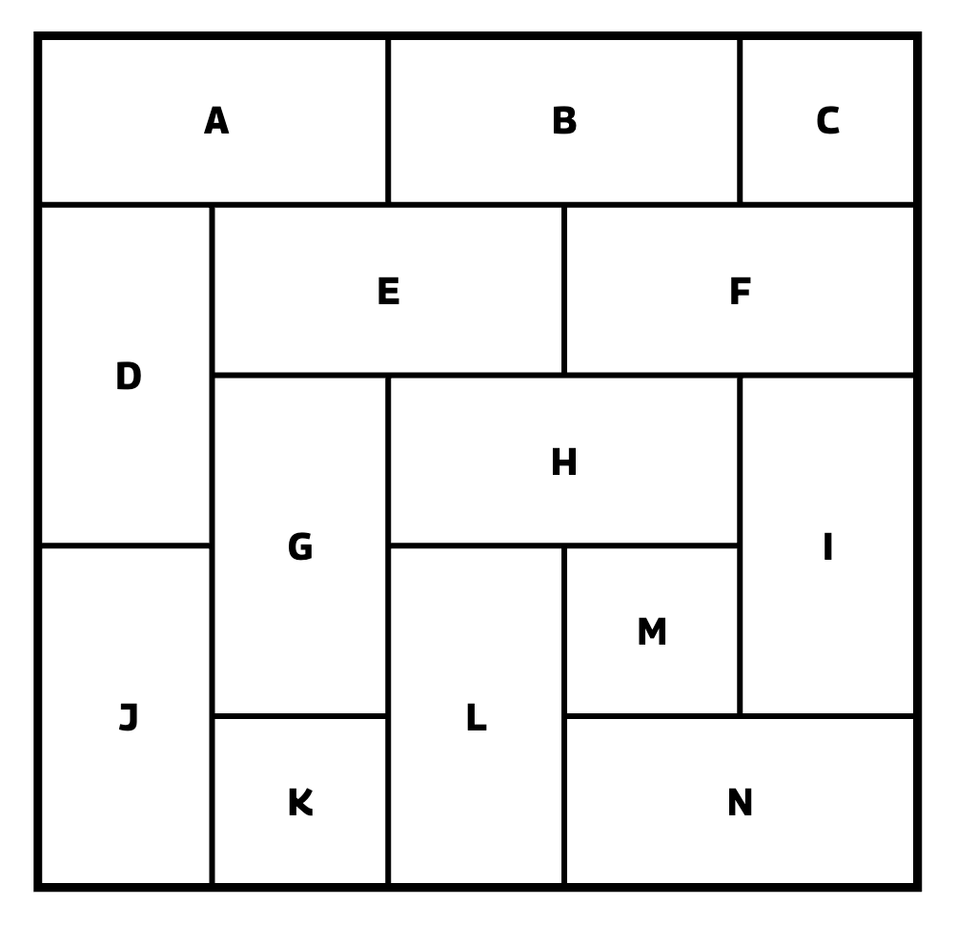

- Each guest uses two plots that border one another.
- Plot E borders both of Taylor’s plots and one plot each used by Frank, Karen, Jessica, and Charles.
- Plot G borders both of David’s plots and one plot each used by Beth, Charles, Frank, and Taylor.
- Plot H borders both of Jessica’s plots and one plot each used by Beth, Charles, Frank, and Taylor.
- The four corner plots contain broccoli, carrots, green beans, and radishes.
- The plots containing asparagus and lettuce both border the plots containing squash and tomatoes, and all four of these vegetables are in plots used by different guests.
- The plots containing asparagus and peas both border the plots containing cucumbers and turnips, and all four of these vegetables are in plots used by different guests.
- The plots containing asparagus and squash both border the plots containing tomatoes and turnips, and all four of these vegetables are in plots used by different guests.
- The plots containing asparagus and turnips both border the plots containing cucumbers and squash, and all four of these vegetables are in plots used by different guests.
- The plot containing peppers borders the plots containing green beans and potatoes but does not border a plot used by Frank.
- One of Jessica’s plots borders the plots containing potatoes and radishes.
- David’s plots do not contain broccoli or lettuce, nor do they border plots containing either squash or tomatoes.

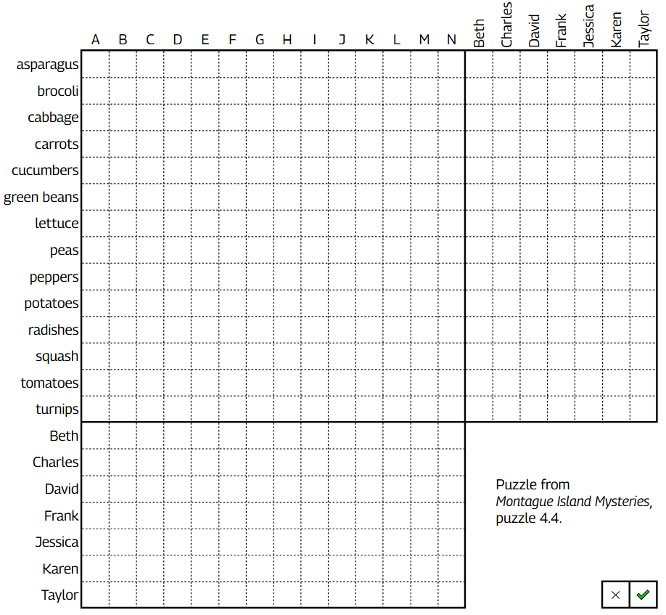

From Montague Island Mysteries puzzle 4.4.
#5: Murder mystery

A murder has occured! Alistair the butler is innocent, but one of the staff and one of the guests are guilty! Their statements cannot be trusted. All other statements are true!

Staff statements:
- Alistair: Either Jessica is innocent, Evelyn and Sandy are both innocent, or all three are innocent.
- Evelyn: If Beth is guilty, then so is either Grant or Lyle. If Jessica is guilty, then Grant and Lyle are innocent.
- Grant: If Molly or Sandy is guilty, then Beth, Charles, and Karen are innocent. If Lyle is guilty, then David, Frank, and Jessica are innocent.
- Lyle: If Evelyn is guilty, her accomplice is David, Frank, or Jessica.
- Molly: If Frank is guilty, his accomplice is either David or Evelyn. If Karen is guilty, her accomplice is Grant or Lyle; but if David is guilty, Grant and Lyle are innocent.
- Sandy: If Charles is guilty, then so is either Grant or Lyle. If Grant is guilty, then David, Frank, and Jessica are innocent.

Statements by the guests:
- Beth: If Evelyn is guilty, then David and Frank are innocent. If Molly is guilty, then David and Jessica are innocent.
- Charles: If Sandy is guilty, then David and Frank are innocent.
- David: If Beth is guilty, her accomplice is not Grant or Lyle. If David is guilty, his accomplice is not Evelyn or Sandy.
- Frank: If Grant or Lyle is guilty, then Beth and Karen are innocent. If Molly is guilty, then her accomplice is Beth, Charles, or Karen.
- Jessica: If Grant or Lyle is guilty, then Charles and Karen are innocent.
- Karen: If Charles is guilty, his accomplice is either Evelyn, Molly, or Sandy. If Frank is guilty, Evelyn and Sandy are innocent.



Puzzle from Montague Island Mysteries, puzzle 12.4.
#6: Pilfer puzzle

A robbery has occurred in the same mansion! Fewer than 4 guests were the thieves. Their statements may be true or false. All other statements are true! Police investigation has also shown that neither Danny nor Brianna makes a true statement unless he or she is innocent.

- Aria: Either Brianna or Cheryl is guilty, but not both.
- Brianna: Cheryl is innocent, and there were three thieves.
- Cheryl: Steven is innocent, and there were three thieves.
- Danny: Either Kelly or Steven is guilty, but not both.
- Kelly: I am innocent, and there were two thieves.
- Steven: I am innocent, and there were three thieves.
- Taylor: Either Aria or Danny is lying, but not both.

Puzzle from Montague Island Mysteries, puzzle 12.4.
Bonus: Frame-up

On Saturday morning, Sandy was found stabbed to death in the old hut. Witnesses confirmed that Sandy had left the mansion at 9:45 a.m., heading toward the hut. In Sandy’s room, police discovered a note indicating that Henry had asked to meet there at 10:30 a.m. to discuss a matter of great importance. Further investigation revealed that both Sandy and Henry had a reputation for swindling people—many of whom were relatives of the other guests. Only guilty parties—of which there were no more than two—may make false statements. All others are true.

Statements from the staff:
- Alistair: After learning of the murder at 11 A.M., we checked all the guest rooms for the letter openers that are found in each room’s desk, and only Henry’s was missing. Guest room doors are not usually locked, so anyone could have taken it.
- Charlotte: Amanda and Madison left the mansion early, though not at the same time, saying they intended to go sailing. Sailing from the marina to the windmill this morning, or from the windmill to the marina, would have taken under two hours.
- Evelyn: Dawn and Thomas were in the dining room this morning from 7:45 to 8:15. Henry and Lee were there from 8:00 until 9:00.
- Grant: Most of the guests trust one another enough, and are unscrupulous enough to conspire with another guest to commit a murder. However, Amanda, Henry and Taylor do not trust one another; and Dawn, Lee, and Madison do not trust one another. If anyone in either of these groups of three is guilty, neither of the other two in the group could have been an accomplice.
- Lyle: Sandy was stabbed in the throat with a letter opener of a kind that is found in every guest room’s desk. The time of death was between 10 and 10:30.

Statements by the guests:
- Amanda: I left the mansion at 7 A.M. and returned at 1 P.M. after I sailed all the way around the island in a clockwise direction (as viewed on a map) in one of the marina’s sailboats. I noticed another sailboat tied to an old dock at the windmill, but I didn’t see anyone with it. I saw no other sailboats outside of the marina.
- Dawn: I had breakfast in the dining room from 7:45 until 8:15. Afterward I stayed in the mansion all morning, in the lounge and library.
- Henry: I came downstairs to the dining room at 8:00. After returning to my room at 8:30, I found a typewritten note had been slipped under my door since I left; it said that Sandy wanted to meet me at the old hut at 10:30 to discuss a matter of importance. I stayed in my room, using my letter opener at my desk, until I left the mansion at 9:45. When I reached the old hut, I found Sandy’s body. Just then, Lee showed up and accused me of killing Sandy.
- Lee: After returning from breakfast at 8:30, I found a typewritten note that hadn’t been there when I left my room at 8:00, saying that Sandy and Henry were going to meet at the old hut between 10:30 and 10:45 to discuss an important business opportunity, and they wanted to offer me an opportunity to participate. I left the mansion shortly before 10:00. When I reached the old hut, I found Henry bending down over Sandy’s body, and I phoned the mansion with the news. We waited there until Lyle arrived to examine the body.
- Madison: I left the mansion at 7:30 A.M. and returned at 1 P.M. after I sailed all the way around the island in a counterclockwise direction (as viewed on a map) in one of the marina’s sailboats. I noticed another sailboat tied to an old dock at the windmill, but I didn’t see anyone with it. I saw no other sailboats outside of the marina.
- Taylor: I had a leisurely breakfast in the dining room from 8:00 until 9:00. After that I took a walk, not returning to the mansion until 11:00.
- Thomas: I had breakfast in the dining room from 7:45 until 8:15. After that I took a long walk, not returning to the mansion until 11:00.

